**Aim -** Our aim is topredict the reasons for users adopting our product.

**Adopted User** - is a user who has logged into the product on 3 separate days in at least one 7-day period. (ie: The most frequent users of the product).

* There were 1656 adopted users out of 8823 users of the product.

**Important Factors determining Adopted users:**

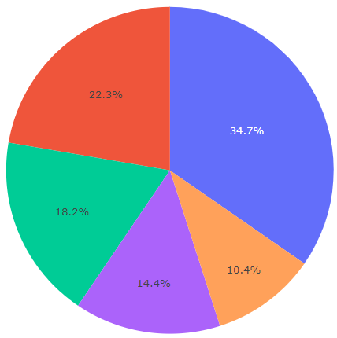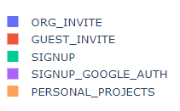

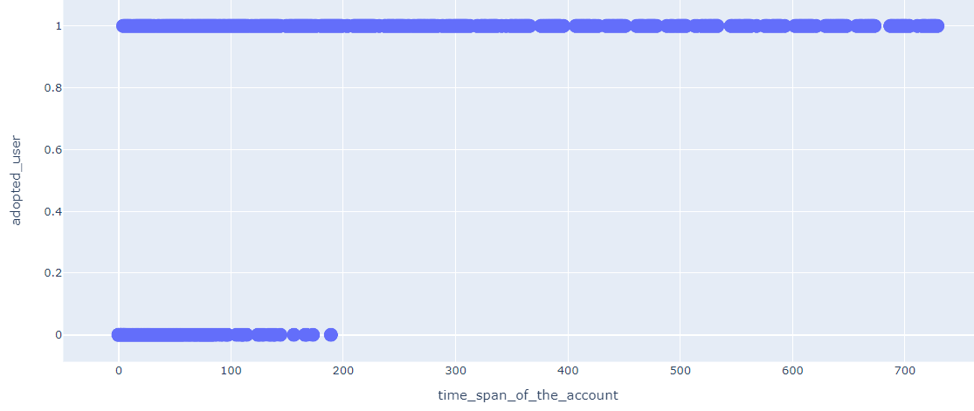

**Interpretation of the results:**

* User adoption is higher when Creation_Source  (how  their  account  was  created) is through Organisation invite & Guest invite. That is, When the user is invited to an organisation as a “full member (35%)” or “as a guest (22%)”.
* User adoption is higher when time span between the account created and last time it was used is more than 200 days.

**Solution:**

* By Inviting users through Organisational invite , and by retaining users for a more than 200 days --- we can increase the “future user adoption” .